For Immediate Release

Hong Kong Design Centre Curates and Presents:
‘Chubby Hearts Hong Kong’ Officially Kicks Off on Valentine’s Day
11-Day Centre Piece at Statue Square Gardens, Central and
Pop-ups Across the City from 14 to 24 February 2024

#CHUBBYheartsHK
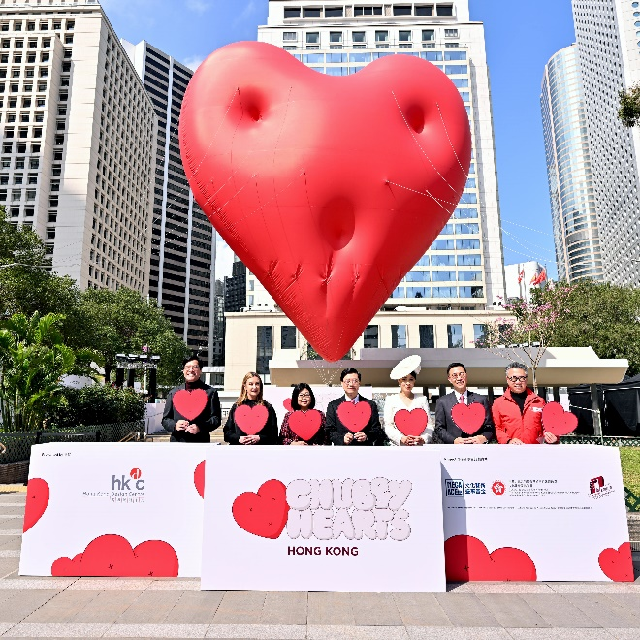

Hong Kong, 14 February 2024 – ‘Chubby Hearts Hong Kong’, a public design and art project curated and presented by Hong Kong Design Centre (HKDC) opens today, spreading love and unexpected joy in the city with oversized, heart-shaped design installations. The project is financially supported by the Mega Arts and Cultural Events Fund under the Culture, Sports and Tourism Bureau of the Hong Kong Special Administrative Region (HKSAR) Government.

Chubby Hearts project was conceived by world-renowned designer and artist Anya Hindmarch in 2018, it swiftly became a global design sensation. This marks the first time that the Chubby Hearts project is being showcased outside of London, the UK, and being presented in a new format and expanded to a larger scale in Hong Kong from 14 to 24 February 2024.

The project demonstrates how creative solutions can bring unexpected joy through simple and whimsical designs of floating hearts at unexpected locations in the city. These delightful installations have the power to make people smile, infuse a positive atmosphere, and spread love throughout the urban landscape. Anya was awarded a CBE (Commander of the Order of the British Empire) in 2017 in recognition of her contribution to the industry.

The Chubby Hearts centre piece with a diameter of approximately 12 meters will appear at the Statue Square Gardens in Central from 1pm to 9pm for 11 days. Surprise pop-up Chubby Hearts with a diameter of approximately 3 meters will appear at various iconic landmarks and scenic spots across the city. These locations include:

- Belcher Bay Promenade, Kennedy Town
- Central Market
- Central & Western District Promenade (Central Section)
- Clock Tower, Tsim Sha Tsui
- East Coast Park Precinct, North Point
- Flower Market, Mong Kok
- Hong Kong Maritime Museum, Tsim Sha Tsui
- Woo Cheong Pawn Shop, Wan Chai
- Kweilin Street, Sham Shui Po
- Lam Tsuen Wishing Square, Tai Po
- Ngong Ping Village, Lantau Island
- Peak Road Garden (The Peak)
- Peak Galleria
- PMQ, Central
- Tai O
- Temple Street, Jordan

Locations and timings of the pop-up Chubby Hearts will be announced every morning on HKDC’s website (www.hkdesigncentre.org) and its offical social media plaforms (Facebook: www.facebook.com/hkdesigncentre and
Instagram: www.instagram.com/hkdesigncentre ).

The Guest of Honour, Mr. John Lee, the Chief Executive of the HKSAR, extends warm greetings to launch this public design project. Other officiating guests attending the launch event today include Mr. Michael Wong, the Deputy Financial Secretary of the HKSAR Government; Mr. Kevin Yeung, the Secretary for Culture, Sports and Tourism of the HKSAR Government; Prof. Eric Yim, the Chairman of Hong Kong Design Centre; Ms. Anya Hindmarch, Designer of Chubby Hearts, and Ms. Carina Lau, renowned actress and Design & Creative Tourism Ambassador of Chubby Hearts Hong Kong.

Ms. Anya Hindmarch, Designer of Chubby Hearts says, ‘I am thrilled to be able to fly the Chubby Hearts over Hong Kong, one of my favourite cities in the world. I hope the installation brings a fun surprise to this vibrant, creative city, while spreading a little joy.’

Ms. Sam Lam, Curator and Project Director of Chubby Hearts Hong Kong says, ‘At Hong Kong Design Centre, we believe in the transformative power of good design to enrich our community and uplift lives. The Chubby Hearts project is recognised as one of the best creative placemaking cases in the world, showcasing how creative solutions have the ability to spread unexpected joy. By floating Chubby Hearts in unexpected city locations, it not only reminds us of design’s capacity to connect people and communities and create places for well-being, it also has the capacity to generate new business opportunities in sectors like tourism and retail. Ultimately, public design projects like this will breathe life into our cityscape, creating an atmosphere that can be enjoyed by all.’

Mr. Adrian Cheng, Chairman of Mega Arts and Cultural Events Committee says, ‘I’m delighted to see the Chubby Hearts flying around the city, celebrating the love shared by all of us who call Hong Kong home. This spectacular project is curated to shine the genuine collaboration in bridging the East and West cultures. It spotlights Hong Kong as an open platform for creativity and talents, and it will always be.’

Collaborating with cross-disciplinary local creative units, the project aims to foster design and cultural exchange while celebrating the city’s East-meets-West heritage throughout the Valentine’s Day to the Chinese Valentine’s – Lantern Festival. Creative line-ups include: composer Leon Ko creates an original music for the project; new media designer Nelson Ng creates a Chubby Hearts animation for Hong Kong; award-winning photographer Dr Victor Wong captures the beauty of Hong Kong with the flying Chubby Hearts; travel photographer Derek Tang produces a creative short reel; and artist Tommy Fung of SurrealHK creates his signature surreal image.

‘We are delighted to collaborate with Anya, a globally acclaimed pioneering designer, as well as local creators, for hosting this event. Together, we aim to promote the principles of sustainability and inspire the public towards sustainable development,’ Ms. Sam Lam adds.

Chubby Hearts Hong Kong takes a new exhibition format with the support from Motion City Partners, showcasing Chubby Hearts’ captivating motion and graphic design works by local creators on over 100 screens and vehicles throughout Hong Kong. This innovative approach transforms the city into an open-air gallery, offering a unique and immersive experience for all to enjoy.

A special highlight is the newly sponsored Chubby Hearts digital artwork displayed on the Sino LuminArt Facade at Tsim Sha Tsui Centre and Empire Centre from 14 to 24 February 2024. The work showcases the beauty of Hong Kong’s skyline, illuminating and spreading boundless love over the iconic Victoria Harbour.

In addition, to promote love and inclusivity in the neighbourhood, Hong Kong Design Centre has collaborated with the Central and Western, and Sham Shui Po District Offices; Sham Shui Po Community Living Room under the Lok Sin Tong Benevolent Society Kowloon; Shine Skills Centre under the VTC Group; and the Strive and Rise Programme. Throughout the project period, a series of educational guided tours will be organised for nearly 150 underprivileged children and youths, fostering inclusiveness within the community and providing valuable learning experiences for the participants.

Heavy rain and strong winds can impact the operation of the outdoor floating installation. For safety reasons, the normal display is restricted to 6 to 8 hours per day, and an exclusion zone is established around the installation. The exact number of display days and timings may vary depending on the actual weather conditions. Visitors are advised to stay tuned to Hong Kong Design Centre’s Facebook and Instagram Story for the latest news before visiting the installations.

Download photos at: https://www.dropbox.com/scl/fo/qfskk4c9ohybd0rqnkg6a/h?rlkey=ouf44e49p5achd56vbt5meqdu&dl=0

Media Enquiries

Integrated Publicity Services Limited
Sam Au | sam@ipshkg.com | (852) 9211 7760
Cathy Lau| cathy@ipshkg.com | (852) 9777 0067

Hong Kong Design Centre
Candy Yuen | candy.yuen@hkdesigncentre.org | (852) 3793 8471 / 6379 3729
Coco Wong | coco.wong@hkdesigncentre.org | (852) 3793 8429 / 6037 9220

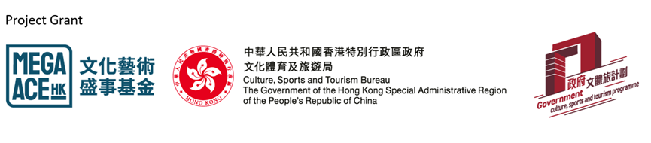

About Hong Kong Design Centre
Hong Kong Design Centre is a strategic partner of the Hong Kong Special Administrative Region Government in leveraging the city’s East-meets-West advantage to create value from design.

To achieve our goals we:
- Cultivate a design culture
- Bridge stakeholders to opportunities that unleash the value of design
- Promote excellence in various design disciplines

Learn more about us at www.hkdesigncentre.org

About Mega Arts and Cultural Events Fund (Mega ACE Fund)
The Mega ACE Fund set up by the Culture, Sports and Tourism Bureau of the Hong Kong Special Administrative Region Government aims to attract and support international and large-scale arts and cultural events to anchor in Hong Kong. It targets mega arts and cultural events in Hong Kong organised by the private sector or non-governmental organisations, with a view to developing Hong Kong into an arts and cultural metropolis, providing opportunities for the arts and cultural sector to flourish, as well as fostering Hong Kong’s development as an East-meets-West centre for international cultural exchange.

About Chubby Hearts
Chubby Hearts is a public design project conceived by fashion designer Anya Hindmarch. Giant chubby heart balloons fly over, or are squashed into famous landmarks, as a declaration of love to a city. The project first appeared in London in 2018, reappearing in 2019 and 2022 supported by the Mayor of London, the British Fashion Council and the City of Westminster to spread a little love. For 2024, the project is travelling outside of the UK for the first time to shine a light on the creative and inspiring city of Hong Kong.

Learn more about Anya Hindmarch, Designer of Chubby Hearts: https://www.anyahindmarch.com/blogs/experience/about-anya

Motion City Partners of Chubby Hearts Hong Kong
Chinachem Group, Chinese Estates Holdings Limited, Emperor Group, Hang Lung Properties, Henderson Land Group, Hong Kong Tramways, Hysan Development, LAWSGROUP, Lee & Man Group, Leisure and Cultural Services Department, MTR Corporation, Nan Fung Group, Sino Group, Wharf Estates Limited and many more.

Special Thanks of Chubby Hearts Hong Kong
Central and Western District Office, Civil Aviation Department, Chinachem Group, Hang Lung Properties, Highways Department, Hong Kong Maritime Museum, Islands District Office, K.Wah International Holdings Limited, Lam Tsuen Wishing Square, Lands Department, Leisure & Cultural Services Department, Ngong Ping 360, PMQ, Sham Shui Po District Office, Tai Po District Office, Transport Department, Urban Renewal Authority, Yau Ma Tei Temple Street Association of Hawkers and Shop Operators, Yau Tsim Mong District Office.

The Government of the Hong Kong Special Administrative Region provides funding support to the Chubby Hearts Hong Kong only, but does not otherwise take part in it. Any opinions, findings, conclusions or recommendations expressed in the activities (or by members of the grantee’s team) are those of the organisers of Chubby Hearts Hong Kong only and do not reflect the views of the Government of the Hong Kong Special Administrative Region.

