For immediate release 7 October 2021

Envision the Future as Business of Design Week 2021
Presents ‘Global Design Reset’

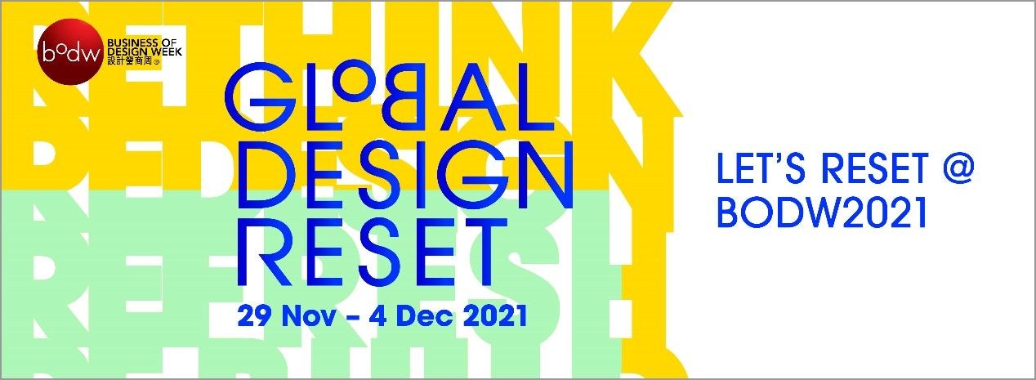
From 29 November to 4 December, discover new possibilities and innovations in
the great “reset” facing our world at Asia’s premier design conference

Over 80 speakers with creative minds from leading companies ranging from
Animoca Brands, Archi-Tectonics, Christie’s, FILA, Heatherwick Studio, Jason Bruges Studio, Jones Lang LaSalle IP, Inc. (JLL), Massive Change Network, Mecanoo, MillerKnoll, Six Senses Hotels Resorts & Spas to Studio Zhu-Pei, among others

Following almost another year filled with disruption, major shifts are emerging across industries. How to prepare for ongoing transformations and learn to better ride the wave of the new normal requires, among other things, decisive leadership, cross-disciplinary collaboration and boundless creativity inspired by human-centred design.
Drawing on the essence of inclusivity, sustainability, and design and technology, Asia’s premier annual event on design, innovation and brands since 2002, Business of Design Week (BODW) organised by Hong Kong Design Centre (HKDC) gathers some of the world’s foremost design masters, brand leaders and entrepreneurs from Hong Kong as well as overseas, driving discourse on the value of design and innovation to inspire global audiences.

With the UK and ViuTV as strategic partners this year, the weeklong BODW provides the opportunity for global business and creative leaders to exchange insights, interact, and explore opportunities for collaboration. The theme of BODW 2021 is Global Design Reset, underlining this remarkable period that is bearing witness to significant change across various industries all over the world. Leading entrepreneurs, creatives, and designers from different sectors will shine a light on how we can thrive amid challenges, co-create a sustainable future, and make a meaningful impact through design.

Following last year’s success, the BODW 2021 Summit on 1 – 4 December 2021 will be held as a hybrid programme, simulcast live on ViuTV, online, social media, and at partner locations. The Summit explores eight main pillars of topics: Brand Rejuvenation, Connected Health and Wellbeing, Creative Mindset & Innovation Leadership, Culture & the City, Designing an Intelligent Future, Hospitality with Purpose, New Urban Models, and Phygital Reality.
The key speaker line-up of this year’s Summit includes:
- Ascan Mergenthaler, Senior Partner of Herzog & de Meuron (Switzerland)
- Bruce Mau, Chief Executive Officer of Massive Change Network and Founder of Bruce Mau Studio (US)
- Bill Bensley, Founder & Interior Designer of BENSLEY (Thailand)
- Brian Yiu, CEO of Fila China (Mainland China)
- David Schonthal, Clinical Professor and Director of Entrepreneurship Programs, Kellogg School of Management; and book author of The Human Element: Overcoming the Resistance that Awaits New Ideas (US)
- Eric Quint, former Chief Brand and Design Officer of 3M, and book author of Design Leadership Ignited: Elevating Design At Scale (The Netherlands)
- Francine Houben, Founding Partner of Mecanoo (The Netherlands)
- Freeman Lau, Founder of KL&K Creative Strategics (HK)
- Jason Bruges, Director of Jason Bruges Studio (UK)
- Jonathan Cheung, Advisor of GAP Inc. (US)
- Li Hua, Founder & Principal of Trace Architecture Office (Mainland China)
- Lofai Lo, Director & General Manager of ViuTV (HK)
- Martin Darbyshire, CEO of tangerine (UK)
- Neil Jacobs, CEO of Six Senses Hotels Resorts & Spas ( Singapore)
- Paul Priestman, Designer & Chairman of PriestmanGoode (UK)
- Pei Zhu, Founder of Studio Zhu-Pei (Mainland China)
- Richard Ekkebus, Director of Culinary Operations and F&B of The Landmark Mandarin Oriental, Hong Kong (HK)
- Robert Greenwood, Managing Director Asia of Snøhetta (HK)
- Sara Mao, Vice President and Director, Christie’s Education Asia Pacific, of Christie’s (HK)
- Steve Leung, Founder of Steve Leung Design Group Limited (HK)
- Suhanya Raffel, Museum Director of M+ (HK)
- Thomas Heatherwick, CBE, Founder of Heatherwick Studio (UK)
- Tiffany Lau, Executive Director and Head of Urban Ecosystems, Asia Pacific, of Jones Lang LaSalle IP, Inc. (JLL) (HK)
- Tino Kwan, Principal Consultant of TinoKwan Lighting Consultants Limited (HK)
- Prof. Winka Dubbeldam, Founder & Partner of Archi-Tectonics NYC; Miller Professor & Chair of Weitzman Architecture of University of Pennsylvania (US)
- Yat Siu, Co-Founder & Chairman of Animoca Brands (HK)
- Yenn Wong, CEO & Founder of JIA Group (HK)
- and others

In addition to the Summit scheduled for December 2021, HKDC will also soft launch a new design knowledge platform ‘bodw+’ in October 2021. The ‘bodw+’ is envisioned to become Asia’s leading online design portal promoting and celebrating design excellence, inspiring and engaging the local and international design community, and connecting overseas regions and the Mainland, especially the Guangdong-Hong Kong-Macao Greater Bay Area. This platform will feature the latest insights on seminal design trends, and exclusive interviews with creative leaders and emerging talents.

Join BODW 2021 and Rethink, Refresh and Reset with leading entrepreneurs, creatives, and designers from different sectors. Let’s Reset @ BODW2021!

For registration and updates of BODW 2021, please visit the official website at
http://www.bodw.com/ and follow bodw+ on the following social media channels: Facebook (bodw+), Instagram (@bodwplus), Twitter (@bodwplus), LinkedIn (bodw+) and YouTube (bodw+).

BODW is organised by Hong Kong Design Centre (HKDC) and co-organised by Hong Kong Trade Development Council (HKTDC), with Create Hong Kong (CreateHK) of the Government of the Hong Kong Special Administrative Region (HKSAR Government) as the Lead Sponsor.

-End-
Images:
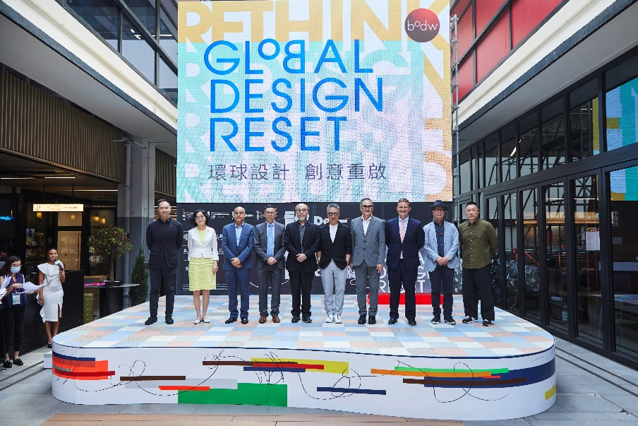
Caption: In attendance at the Business of Design Week (BODW) 2021 kick-off event were 10 officiating guests (From Left to Right): Dr Joseph Wong, Executive Director of Hong Kong Design Centre; Dr Lay Lian Ong, Principal of Hong Kong Design Institute (HKDI); Eric Tong, Head of Advertising, ViuTV; Stephen Liang, Assistant Executive Director, Hong Kong Trade Development Council (HKTDC); Victor Lo, Chairman of BODW Steering Committee; Prof. Eric Yim, Chairman of Hong Kong Design Centre; Victor Tsang, Head of Create Hong Kong; Nick Heath, Director General Trade & Investment of the UK’s Department for International Trade; Prof. Kun-pyo Lee, Dean of School of Design, The Hong Kong Polytechnic University (PolyU) and William To, Executive Director of PMQ
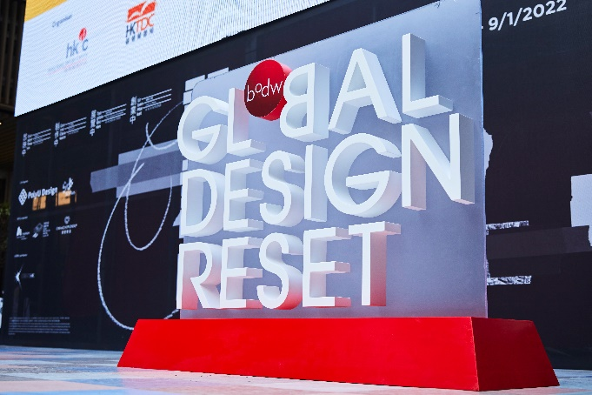
Caption: Hong Kong Design Centre (HKDC) announces this year’s theme for Business of Design Week (BODW): ‘Global Design Reset’
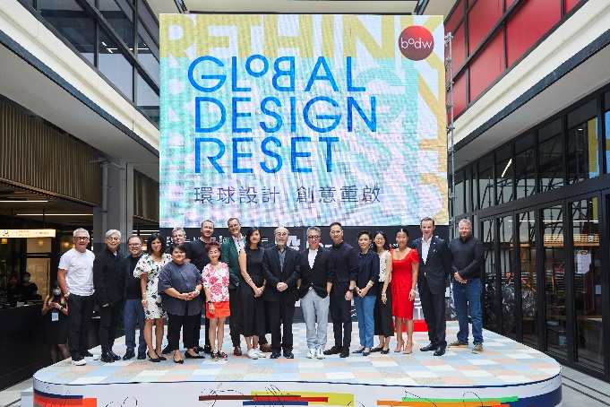
Caption: Local speakers and moderators joining at BODW 2021 Kick-off event including (First Row from Left to Right): Steve Leung, Founder of Steve Leung Designer Group; Tino Kwan, Principal Consultant of TinoKwan Lighting Consultants Limited; Freeman Lau, Founder of KL&K Creative Strategics; Sara Mao, Vice President & Director of Christie's Education Asia Pacific; Cathy Chon, Founder & Managing Director of CatchOn, A Finn Partners Company; Prof. Viveca Chan, Founder of WE Marketing Group; Betty Ng, Founder & Director of Collective; Victor Lo, Chairman of the Business of Design Week Steering Committee; Prof. Eric Yim, Chairman of Hong Kong Design Centre; Dr Joseph Wong, Executive Director of Hong Kong Design Centre; Dr Gina Jiang, Managing Director of Hong Kong Institute of Biotechnology; Janice Leung Hayes, Food Writer & Sustainability Consultant, Honestly Green; Tiffany Lau, Executive Director, Head of Urban Ecosystems, Asia Pacific at JLL; Richard Ekkebus, Director of Culinary Operations and F&B at The Landmark Mandarin Oriental; Jonathan Cummings, President, APAC, of Landor & Fitch; (Second Row from Left to Right) Robert Greenwood, Managing Director Asia of Snøhetta; Chris Dobson, Executive Principal, Asia, Eight Inc. and Guy Parsonage, Partner of PwC Experience Centre
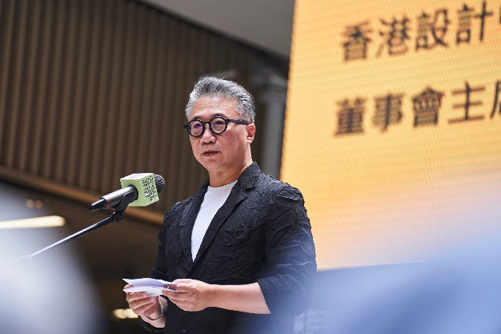
Caption: Prof. Eric Yim, Chairman of Hong Kong Design Centre unveils this year’s BODW programme
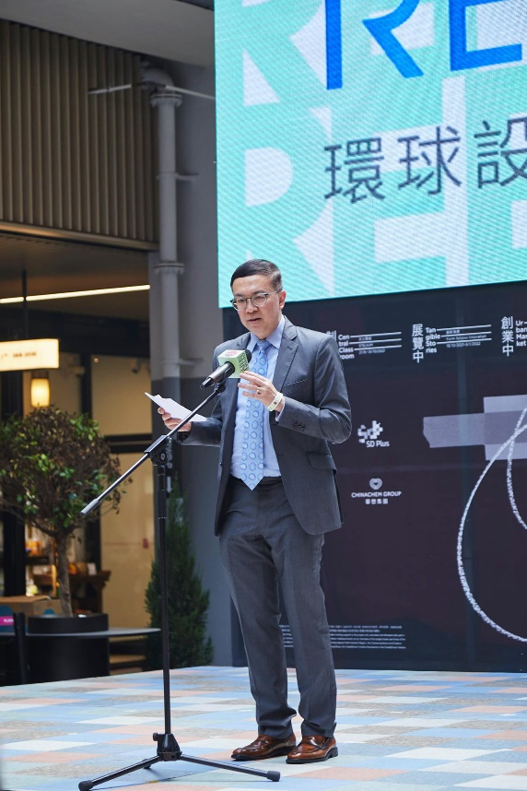
Caption: Stephen Liang, Assistant Executive Director of Hong Kong Trade Development Council (HKTDC), which is a co-organiser, attended the kick-off event
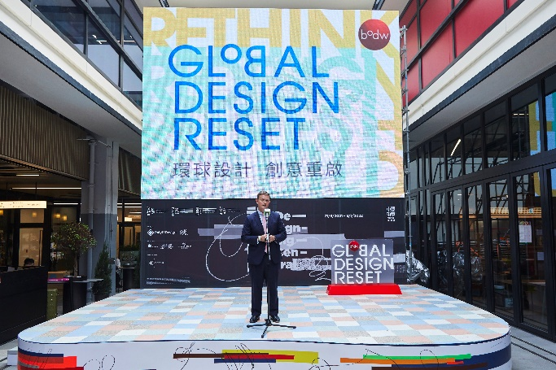
Caption: Nick Heath, Director General Trade & Investment of the UK’s Department for International Trade is joining to announce the continued collaboration of the UK as strategic partner of BODW this year
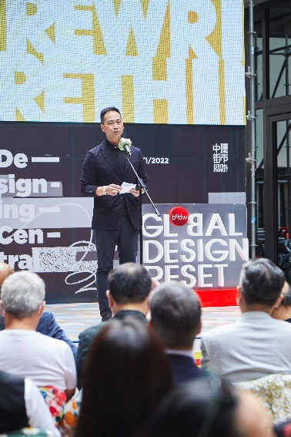
Caption: Dr Joseph Wong, Executive Director of Hong Kong Design Centre introduces the highlights of BODW Summit, as well as a series of creative happenings across Hong Kong and nearby cities running concurrently with the Summit.

High-resolution press images are available for download HERE.

About Hong Kong Design Centre
Hong Kong Design Centre (HKDC) is a non-governmental organisation, and was founded in 22001 as a strategic partner of the HKSAR Government in establishing Hong Kong as an international centre of design excellence in Asia. Our public mission is to promote wider and strategic use of design and design thinking to create business value and improve societal well-being, with the aim of advancing Hong Kong as an international design centre in Asia. Learn more about us at www.hkdesigncentre.org

About Create Hong Kong
Create Hong Kong (CreateHK) is a dedicated agency set up by the HKSAR Government in June 2009. It is under the Communications and Creative Industries Branch of the Commerce and Economic Development Bureau and dedicated to spearheading the development of creative industries in Hong Kong. Its strategic foci are nurturing talent and facilitating start-ups, exploring markets, and promoting Hong Kong as Asia’s creative capital and fostering a creative atmosphere in the community. CreateHK sponsors HKDC to organise the Business of Design Week (BODW) and other projects to promote Hong Kong design. CreateHK’s website: www.createhk.gov.hk.

Press Contact
For further enquiries or interview requests, please contact:
hkdesigncentre@finnpartners.com

Manica Tiglao +852 2807 0899 manica.tiglao@finnpartners.com
Matthew Lai +852 2807 1119 matthew.lai@finnpartners.com

Disclaimer: Create Hong Kong of the Government of the Hong Kong Special Administrative Region provides funding support to the project only, and does not otherwise take part in the project. Any opinions, findings, conclusions or recommendations expressed in these materials/events (or by members of the project team) are those of the project organizers only and do not reflect the views of the Government of the Hong Kong Special Administrative Region, the Communications and Creative Industries Branch of the Commerce and Economic Development Bureau, CreateHong Kong, the CreateSmartInitiative Secretariat or the CreateSmartInitiative Vetting Committee.

