**Business of Design Week 2018 Kicked Off Today**

*Hong Kong SAR Chief Executive Carrie Lam attended as Guest of Honour of today’s opening ceremony for Asia’s premier event on design, innovation and brands*

[HONG KONG – 6 December 2018]

Asia’s leading international event on design, innovation and brands, Business of Design Week (BODW), officially opened today at the Hong Kong Convention and Exhibition Centre. The annual flagship event co-organised by Hong Kong Design Centre and Hong Kong Trade Development Council, BODW consists of a main summit (3-8 December), a BODW City Programme to activate business creative communities in different districts, and over 20 concurrent events to foster innovation and business connections that promote the development of Hong Kong’s creative economy.

Dignitaries including the Honourable **Mrs Carrie Lam**, GBM, GBS, JP, the Chief Executive of the Hong Kong Special Administrative Region, The Honourable **Ms. Linda Dessau AC**, Governor of Victoria, Australia, the Honourable **Dr. Bernard Chan**, JP, Under Secretary for Commerce and Economic Development, **Professor Eric Yim**, JP, Chairman of the Hong Kong Design Centre, **Mr Victor Lo**, Chairman of BODW Steering Committee of the Hong Kong Design Centre, **Ms Margaret Fong**, Executive Director of the Hong Kong Trade Development Council, **Mr Victor Tsang**, Head of Create Hong Kong and **Dr Edmund Lee**, Executive Director of the Hong Kong Design Centre were among those in attendance to officially kick off this year’s event, the 17th edition of the international design and business summit.

Design & Innovation in Hong Kong

Co-organised by the Hong Kong Trade Development Council (HKTDC) and sponsored by Create Hong Kong, BODW aligns with the Hong Kong SAR’s direction of cultivating design thinking and people-centred innovation and promoting wider and more strategic use of design in the city for problem solving, wealth creation and societal wellbeing.

**Mrs Carrie Lam**, GBM, GBS, JP, the Chief Executive of the Hong Kong Special Administrative Region, said at the Opening Ceremony today: “This creative coming together makes smart design sense. It makes great business sense, too. Melbourne and Hong Kong, after all, offer singular strengths in business and design.” She further added, “My Government is also committed to developing design thinking as a problem-solving capability. In the past year, the Design Centre has been organising classes and seminars both at the community level and within the Hong Kong Government. We are now working with the Design Centre to establish an event space, here in the vibrant community of Wan Chai, to enhance public appreciation of design and design thinking.”

A Conversation about Liveability

In collaboration with this year’s partner city Melbourne, which has won the accolade of the world’s most liveable city by the Economist Intelligence Unit for seven consecutive years (2011-2017), BODW continues to provide a platform for business and creative leaders to present the latest innovative ideas and industry insights. This year’s summitwill take on the theme of **‘Think ∙ Collaborate ∙ Create’.** Featuring more than 20 speakers from the city of Melbourne, the event draws inspiration from Melbourne’s strategic and thoughtful approach to design.

Speaking at today’s Opening Ceremony, the Honourable **Ms. Linda Dessau AC,** Governor of Victoria, Australia said: “What makes a great design city? I think it’s a mindset that Melbourne shares with Hong Kong and other great design centres in the world. It’s an understanding that contextually appropriate ideas always underpin the most inspiring original design. Great design is without doubt a collaborative mindset of creativity and conceptual thinking and collaboration. May I thank Hong Kong for gathering design talents from every corner of the globe and for helping to foster that collaborative mindset in this largest design event in Asia.”

Strengthening Hong Kong’s Regional Design Leadership

Each year, BODW brings to Hong Kong some of the world’s most celebrated design masters, brand leaders and business figures across a variety of fields, to inspire both international and Hong Kong audiences on the merits of good design. The annual event serves as a valuable platform for professionals across sectors to network, exchange ideas and explore business collaborations.

**Professor Eric Yim**, JP, Chairman, HKDC said: “As Asia’s leading annual event on design, innovation and brands, Business of Design Week is committed to facilitating cultural exchange and driving innovations in the community. With a stellar line-up of designers from Melbourne and around the world, our week-long programme will explore design-driven innovation and the role of design in the betterment of society. Through this rich context, we hope to continue to champion design as a key driver of innovation and stimulus for economic growth”

Building on the success from previous editions, BODW 2018 is set to explore new frontiers of design in the world of digital design and investigate how technology can enhance our everyday experiences. In addition, the newly introduced ‘Greater Bay Area & Design’ track provides knowledge on how to leverage the business opportunities created under the Greater Bay economic policy spearheaded by the central government of the People's Republic of China.

BODW Summit’s Plenary sessions feature more than 80 international innovators and creative powerhouses from over 15 countries and regions across a multitude of disciplines, including **Martha Thorne**, scholar and executive director of Pritzker Architecture Prize (US); **Li Edelkoort** from Trend Union, one of the world’s leading industry trend forecasters (France); **Prof. Rob Adams AM**, director city design and projects of City of Melbourne (Melbourne); **Ben van Berkel**, founder / principal architect of international design network UNStudio (The Netherlands); **Ron Arad**, acclaimed industrial designer, artist and architect (UK); **Charles Renfro**, distinguished architect and partner of Diller Scofidio + Renfro (US); and **Toyo Ito**, multi-award winning Japanese architect (Japan).

BODW’s extensive range of programmes celebrates design, innovation and brands across various disciplines, covering themes relating to Brands & Innovation, Communication & Design, Design for Asia, Space & Design, Product & Technology, Creative Mindset and Culture & The City. Programme highlights this year include new tracks on Digital & Design, Greater Bay Area & Design, and a special seminar on Liveability, Sports & Design. This year’s Masterclass will feature iconic architect **Carol Ross Barney** to discuss design for social good.

A City-wide Celebration of Design

The week-long event will feature more than 20 events, including the BODW Summit, BODW City Programme and a series of concurrent events, all with the aim of providing a platform for business and creative leaders to exchange ideas, network, and explore new business opportunities.

The BODW City Programme was launched in 2017 as a new extension of BODW, taking the form of an annual creative community activation featuring exciting art installations, exhibitions, creative tours, and education and community programmes. Having made its debut in Wan Chai and other districts in Hong Kong in November, the Programme aims to foster stronger collaborations between local designers, businesses and brands to celebrate good design and innovation, and strengthen Hong Kong as a creative hub in Asia.

Beyond the main programming of BODW, a number of satellite events are also taking place concurrently to celebrate the creative spirit in the city. These include: the DFA Awards Presentation Ceremony, FASHION ASIA HONGKONG, DesignInspire, BIP Asia Forum, deTour, WORKTECH18 Hong Kong, GDN Symposium, M+ Matters Keynote, and the Leadership Forum on Design Education.

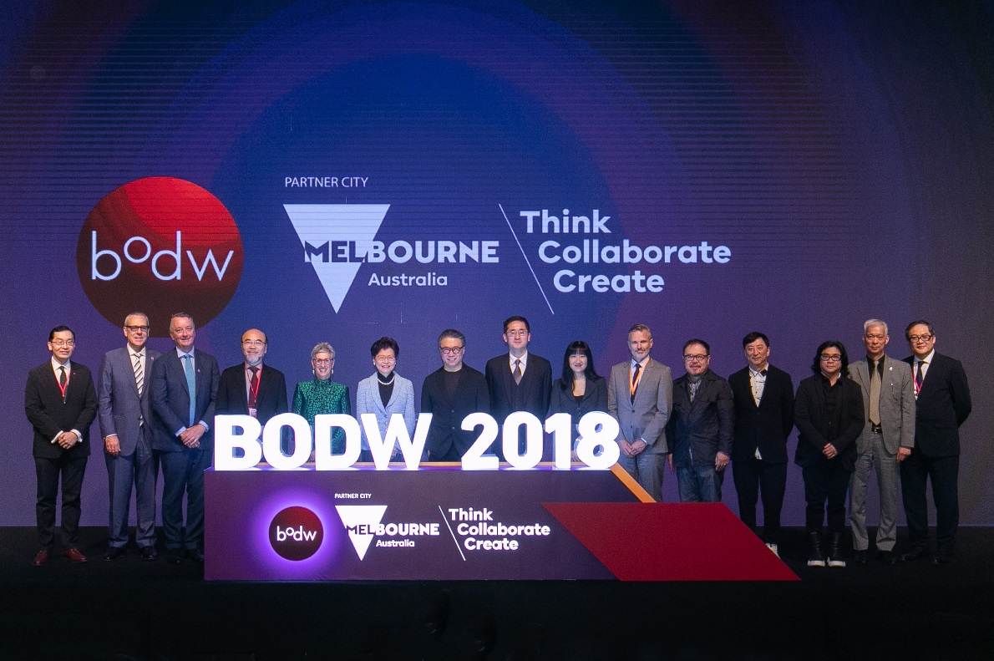

Guest of Honour (GOH): The Honourable **Mrs Carrie Lam Cheng Yuet-ngor, GBM, GBS, JP,** the Chief Executive of the Hong Kong Special Administrative Region; **The Honourable Linda Dessau AC,** Governor of Victoria, Australia; **the Honourable Dr Bernard Chan, JP,** Under Secretary for Commerce and Economic Development; **Professor Eric Yim, JP,** Chairman of Hong Kong Design Centre; **Mr. Victor Lo,** Chairman, BODW Steering Committee of Hong Kong Design Centre; **Mr. Andrew Abbott,** Chief Executive, Creative Victoria; **Ms. Margaret Fong**, Executive Director of Hong Kong Trade Development Council, officially kicked off the 2018 edition of Business of Design Week.

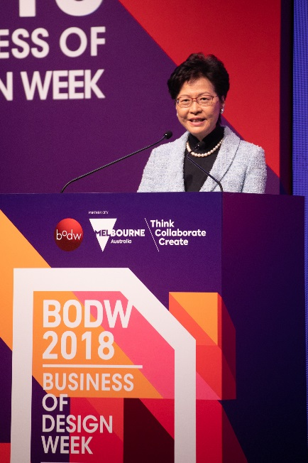

The Honourable **Mrs Carrie Lam Cheng Yuet-ngor, GBM, GBS, JP**, The Chief Executive of the Hong Kong Special Administrative Region, highlighted how her government is committed to developing design thinking as a problem-solving capability.

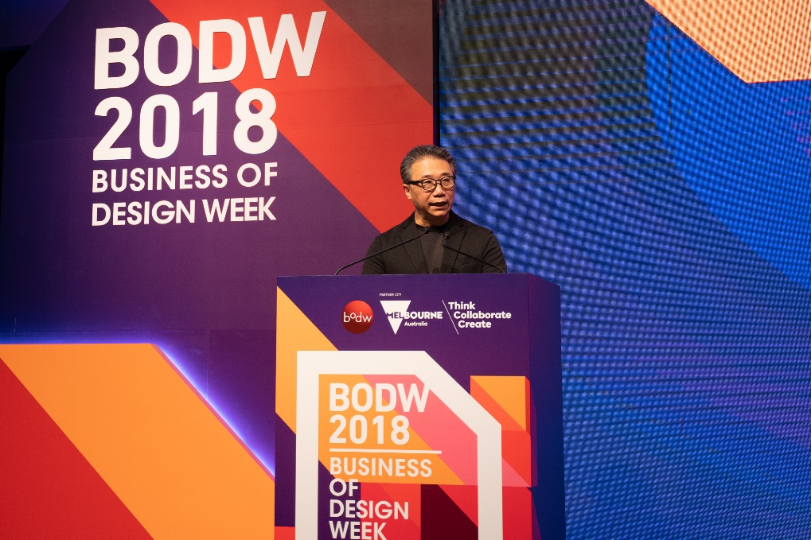

**Professor Eric Yim, JP**, Chairman of Hong Kong Design Centre, shared how the Hong Kong Design Centre is committed to facilitating cultural exchange and driving innovations in the community.

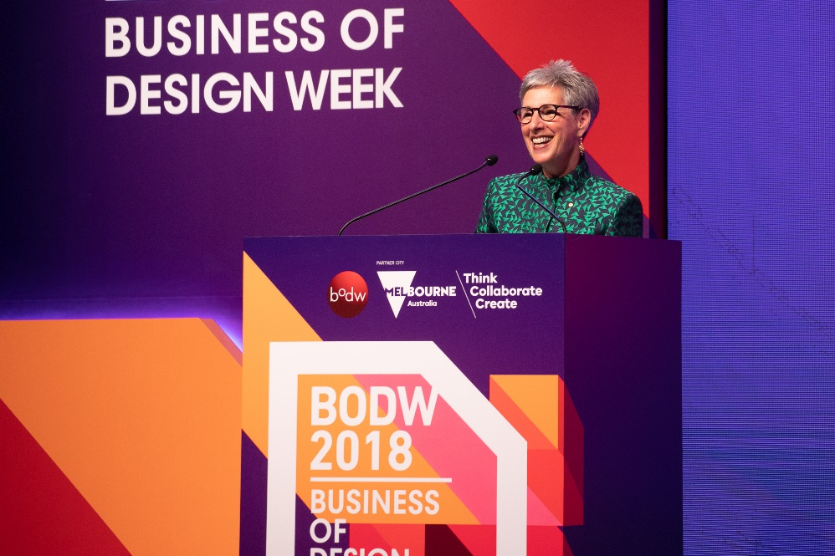

The Honourable **Ms. Linda Dessau AC**, Governor of Victoria, Australia, thanked Hong Kong for gathering design talents from every corner of the globe and for helping to foster that collaborative mindset in this largest design event in Asia.

**NOTES TO THE EDITOR**

More information about this year’s programme can be found at bodw.com.

**About Hong Kong Design Centre**

Hong Kong Design Centre (HKDC) was founded in 2001 as a strategic partner of the HKSAR Government in establishing Hong Kong as centre of design excellence in Asia. HKDC continues its public mission to promote wider and strategic use of design and design thinking to create business value and improve societal well-being. Our initiatives are anchored by five major work directions: CONNECT, CELEBRATE, NURTURE, ADVANCE and ENGAGE.

HKDC’s flagship programmes include Business of Design Week (since 2002) – Asia’s leading annual conference and event on Design, Innovation and Brands; DFA Awards (since 2003) – a widely recognised design awards that celebrates outstanding designs with Asian perspectives; Design Incubation Programme (since 2012) and Fashion Incubation Programme (since 2016) – 2-year incubation programmes to nurture future design and fashion entrepreneurs; FASHION ASIA HONGKONG (since 2016) – a fashion initiative combining conversations, interactions and cultural exchanges to energise the city’s image, and position it as an Asian hub for fashion trade and business development; Knowledge of Design Week (since 2006) – an annual thematic design knowledge sharing platform that explores how design can solve complex challenges of our society.

**Media Contact**

For further enquiries or interview requests, please contact

Sybil Kot | [sybil.kot@ogilvy.com](mailto:sybil.kot@ogilvy.com) | (852) 2884 8529 / (852) 9775 3068  
Gabriel Chan | gabriel.chan@ogilvy.com | (852) 2884 8387/ (852) 61995608